Humanitarian project
public institution " Soligorsky district territorial center for social services of the population»
"The room of psychological unloading»
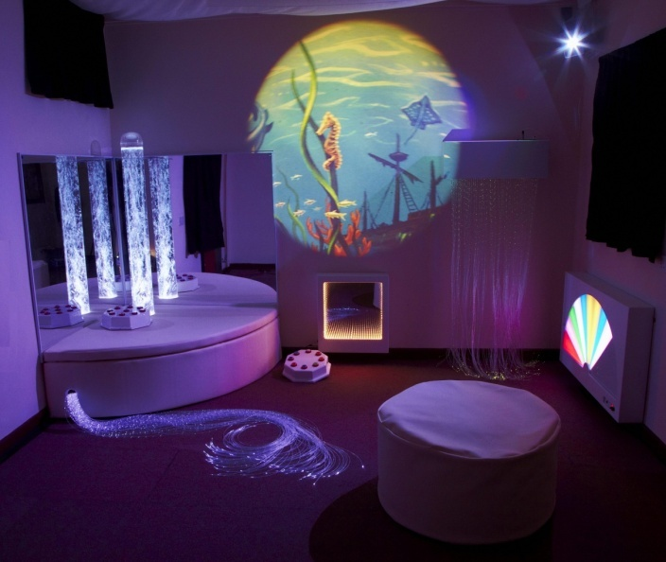
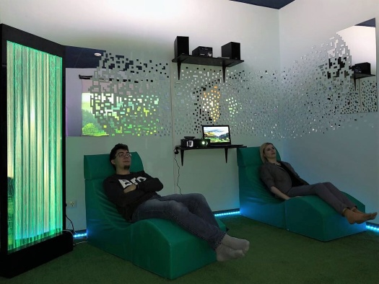
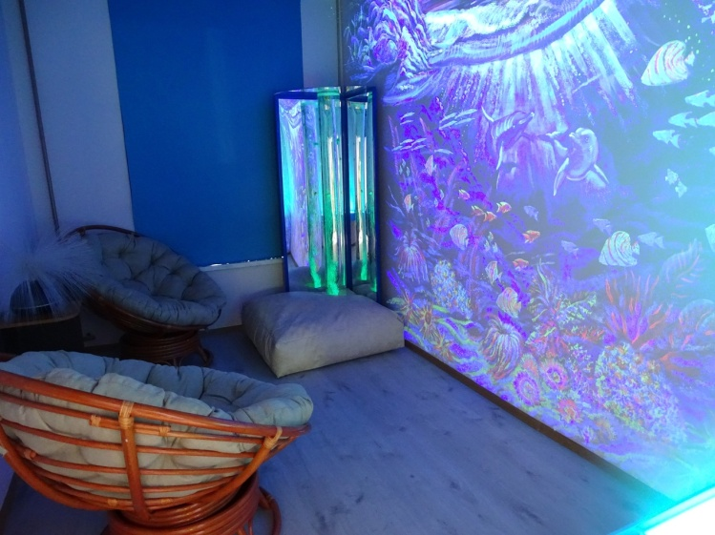

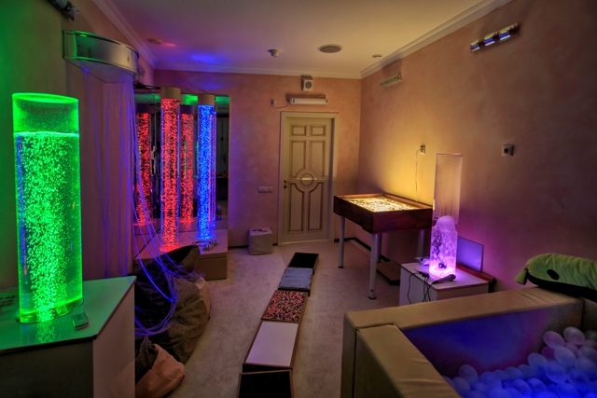
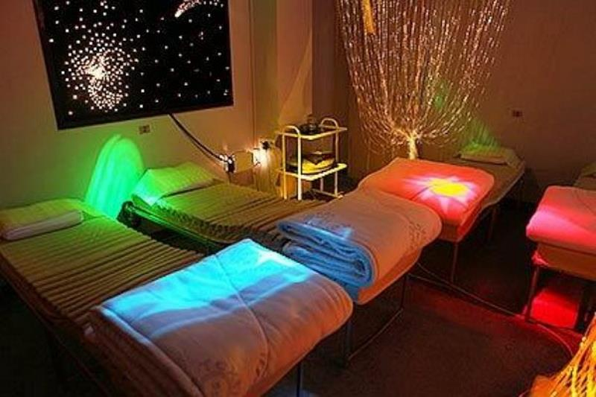

1. Name of project: "the Room of psychological unloading»
2. Implementation period: 2 years
3.The applicant organization offering the project: GU " Soligorsky regional territorial center of social service of the population»
4.The purpose of the project: Creation and equipment of a sensory room in the department of social rehabilitation and habilitation of the disabled of the state institution "Soligosrky district territorial center of social services" for rehabilitation of people with disabilities through providing them with psychological relief, tactile perception, relaxation, recovery-preservation and strengthening of psychophysical and emotional health with the help of multisensory environment.
5. Tasks planned for implementation within the framework of the project:
- establishment and equipping of a room of psychological unloading;
- use of the sensory room-as an innovative model for the development of emotional sphere and communication skills, preservation and strengthening of mental and physical health, the development of self-regulation and relaxation to form the ability to manage their emotional state, increase self-esteem and self-confidence;
- organize classes in the sensory room for people with disabilities.
Touch room helps to solve the following tasks:
- reduce internal anxiety, gain self-confidence, enter a state of rest;
- reduce vegetative-vascular reactions or neurotic disorders;
- stimulate the senses that are weakened or poorly functioning;
- recharge with positive emotions, create a good emotional background.

6. Target group: persons with disabilities of the Soligorsky district visiting the Department of day care for persons with disabilities.
7. Brief description of project activities:
The improvement of the premises;
Interior design (division of the room into 2 zones: relaxation and tactile);
Purchase and installation of equipment (2 types of flooring, soft modules, Ottomans, touch table for sand, equipment with optical and sound effects, touch panels for hands and feet, " starry sky", air-bubble column, aromatherapy unit, salt lamps, gymnastic balls, musical equipment, fiberoptic devices, interactive panels, tactile track, humidifier-ionizer of air), luminous fiber;
Production and distribution of printed materials, information in the media about the activities of the "psychological relief Room", the services provided.
Specialists will conduct classes and complexes of sensory and motor exercises for people with disabilities, these exercises have a positive impact on overall, emotional, speech and social development. One of the known ways of rehabilitation is the developed complex environment - the room of psychological unloading.
This is a specially organized environment, consisting of various kinds of stimulants that affect the organs, vision, hearing, touch, smell.
The sensory room helps to isolate yourself from the outside world, relieve tension, cope with problems, relax and get a charge of positive emotions.
The sensory room can be used to relax people with neurotic and psychosomatic disorders, as well as to stimulate various body functions (hearing, vision, touch, smell, motor functions, speech), to increase the threshold of sensory sensitivity in patients, activation of their brain activity, reduce hyperkinetic muscle tone and restore efficiency.
Classes in the sensory room with the help of relaxation States (muscle relaxation) will help to bring a person out of a tense state. The emphasis is on the support and development of the internal capabilities of the body and the person.
8. Total funding (in us dollars): 10,000
Source of funding amount of funding (in us dollars)
Donor funds 9200
Co-financing 800
9. Project location: 8 Kozlov str., Soligorsk, Minsk region
10.Contact person: Karpovich Veronika Valentinovna, Director, phone 80174234263, e-mail: tsoid@yandex.ru
We will be glad to cooperate!

