The Information Resource Centre «Without stigma. Without barrier» for people with disabilities and special developmental needs
Humanitarian project of the state institution «The territorial centre of social service of the population of Uzda district»
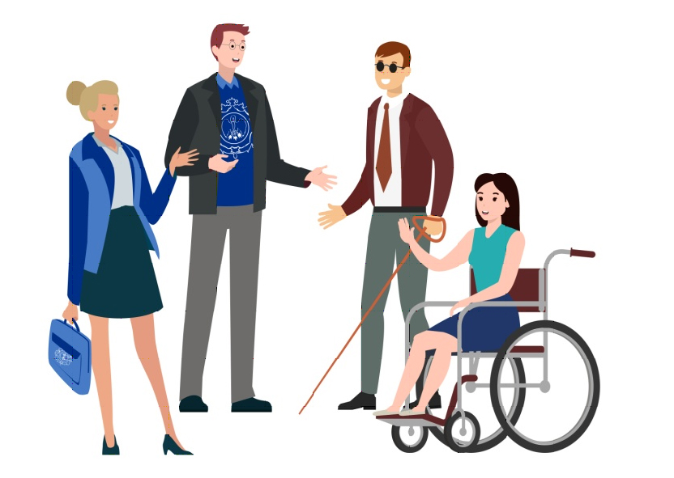
1. The Project name: The Information Resource Centre «Without stigma. Without barrier» for people with disabilities and special developmental needs
2. Time-limits for the realization: 1year (focused on a long-term prospect).
3.The applicant organization:
- The state institution «The territorial center of social service of the population of Uzda district»;
4. Purpose of the project: the creation of conditions for inclusion of people with disabilities and special developmental needs into social life, protection from discrimination.
5. Tasks within the project:
- The judicial education of people with disabilities and special developmental needs, representation of their interests in governmental and other organizations.
- The organization of psychological support to people with disabilities and special developmental needs and to their family members.
- The provision of practical assistance aimed at independent living of people with disabilities and special developmental needs.
- The creation of self-reliance groups and volunteer unit.
- The formation of tolerant society’s attitude towards people with disabilities and special developmental needs.
6. Focus group: people with disabilities and special developmental needs living in the territory of Uzda district.
7. Activities within the project:
- Stage 1 PREPARATORY involves:
– equipping and furnishing of the room by necessary facilities and materials for organization of education sessions, meetings, seminars, round table discussions:
Flipchart INDEX IWB-621 (70*100)
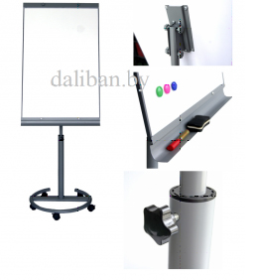
Portable kit «Prezentatsiia comfort»:
– projector Epson EB-X05;
– screen on a tripod Digis DSKD-1105;
– bag for projector Nata;
– electronic pointer;
– cable HDMI
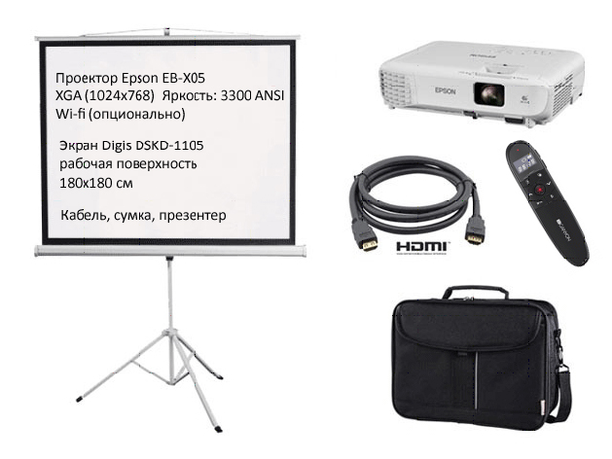
Laptop HP 250 G6 (1WY58EA)

Sound columns Ritmix-2080
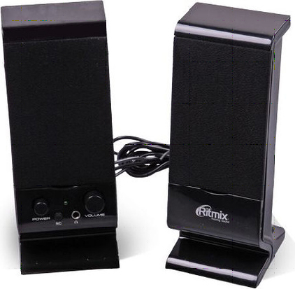
Paper set for flipchart 650*1000 мм, 50 листов
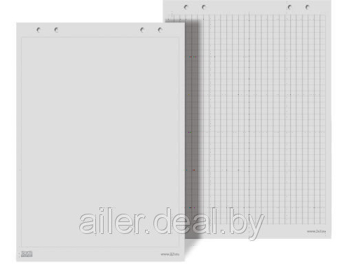
– purchase of special vehicles with lifting device for transportation of the disabled:
Iuniks 3561 – is an accessible passenger minibus on the base of car Gazel 3221, providing transportation of the disabled. For these purposes some tasks are provided:
- Lifting device which makes loading and unloading of the wheelchair smooth and safe.
- Seat belts which provide fixing of the wheelchair.
- Additional lightning of the place of lifting.
- Anti-slip and antistatic coverage of the floor.
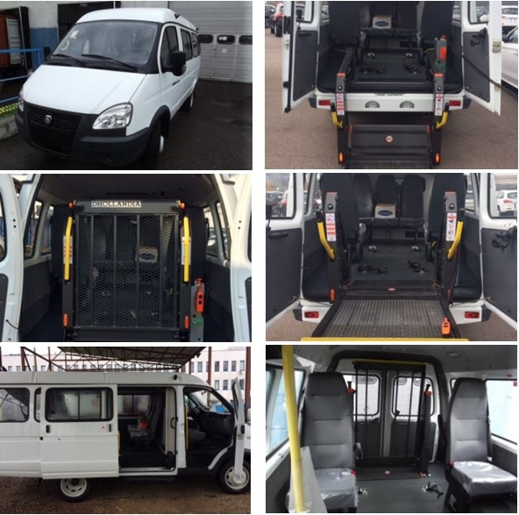
- Stage 2 MAIN involves:
– development of educational programs for people with disabilities and special developmental needs, for their family members on the following blocks:
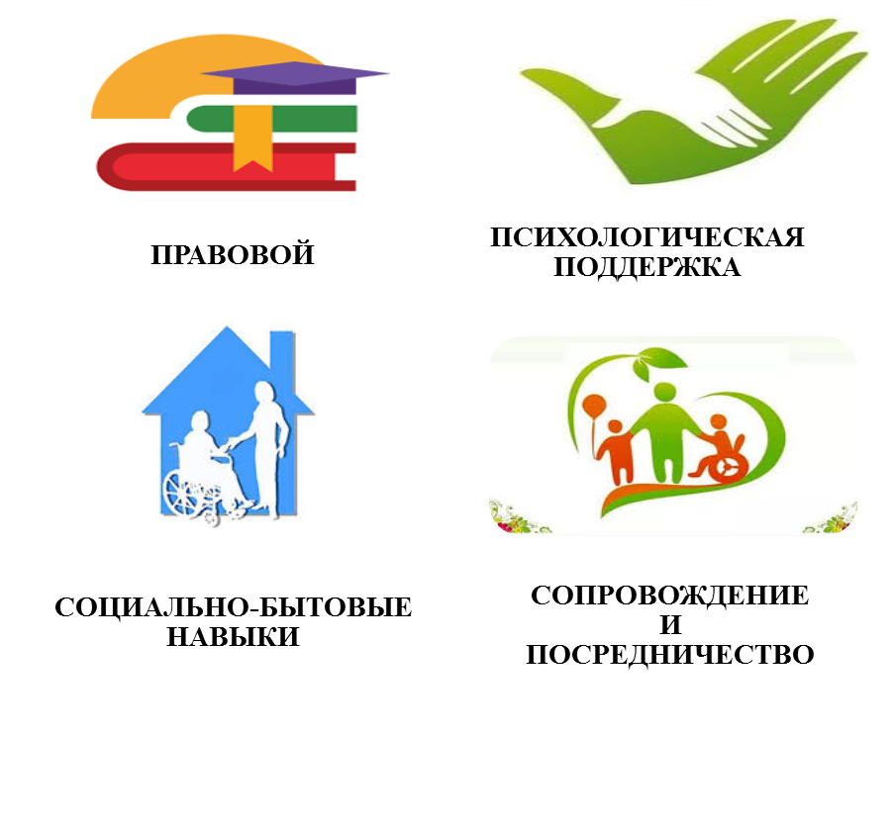
– development of information and outreach programs for population with the aim to form tolerant society’s attitude towards people with disabilities and special developmental needs;
– organization of education sessions, meetings, seminars, round table discussions;
– development of individual plans of maintenance, if necessary;
– organization of motivational activities (excursion trips, cultural and sport events, personal creative exhibitions etc.).
- Stage 3 FINAL involves:
– media coverage of project activities (publications, statements);
– development and distribution of advertising booklets/brochures about realization of the project with demonstrations of positive experience of
inclusion of people with disabilities and special developmental needs into social life;
– monitoring of impact of the project.
8. The total funding (in US dollars): 40 501
Source of financing | Amount of financing  (in US dollars)
Donor funds | 39 501
Co-financing | 1 000
Estimated costs for the project
1.Purchase of special vehicles with lifting device | 36 000
2.Technical servicing of the car, insurance, fuel and lubricants during the warranty period | 2 800
3.Portable kit «Prezentatsiia comfort» | 628
4.Flipchart | 128
5.Laptop | 696
6. Sound columns | 6
7. Paper set for flipchart | 13
8.Organization of motivational activities | 230
9. Location (region/district, city): Minsk region, Uzda
10. Contact person: Zhuk Natalia Alexandrovna – director of the State institution «The territorial center of social service of the population of Uzda district»; (801718) 68710, mobile: (8033)668-82-13;
e-mail: gutcson@uzda.gov.by

